SAP Role Management
We've covered navigation and the different ways to create roles. Now, we're hitting a truly critical section: Authorization Maintenance within Roles. This is where you, as a security administrator, will spend a significant amount of time ensuring that roles provide the precise access needed, securely and sustainably.

Authorization Maintenance in Roles
Authorization maintenance is a cornerstone task for every SAP security administrator. Simply adding applications to a role's menu is not enough to create a functional and secure role. The administration of the role menu, which we've touched upon, forms the basis for the activities we will discuss now: maintaining the actual authorization profiles.
This section will cover all the essentials of authorization maintenance, including the necessary actions, various maintenance options, and understanding the different statuses of authorization objects. We'll explore the prerequisites for working with authorizations according to SAP standards and best practices.
Hint: This section serves as an introduction to the core activities of end-user authorization maintenance, providing fundamental theoretical knowledge.

Prerequisite Knowledge: Before creating or changing roles and diving into authorization maintenance, a fundamental understanding of authorization default values and Transaction SU24 is essential. Please ensure you have reviewed those concepts to avoid common mistakes in role administration.

Authorization Maintenance Buttons
When you navigate to the Authorizations tab of a single role in PFCG, you'll see information about who Created and Last Changed the role, as well as who last generated the role profile (Last Profile Generation). For performing the maintenance itself, two primary buttons are available:
- Change Authorization Data: This button directly takes you into the authorization profile maintenance screen.
- Expert Mode for Profile Generation: This button offers more granular control, especially when dealing with existing profiles.
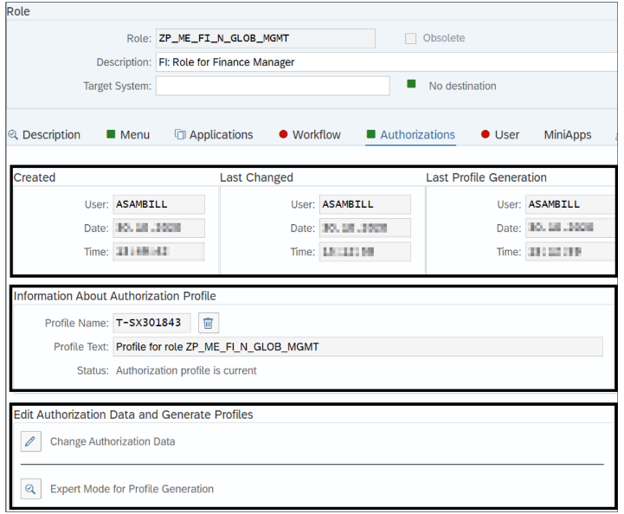
When clicking the "Change Authorization Data" button to maintain an existing authorization profile, you can choose from three further options if you go via the "Expert Mode for Profile Generation" route:
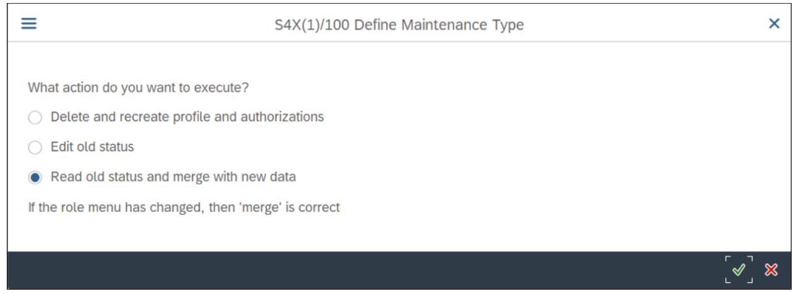
Let's examine these three advanced options:
- Delete and recreate profile and authorizations:
  - This option completely deletes the existing authorization profile for the role.
  - It then pulls fresh proposal data from table USOBT_C (your SU24 defaults) to build a new authorization profile.
  - Important Note: This function does not delete existing organizational level values or any manually inserted authorization objects.
- Edit old status:
  - This allows you to edit the current authorization status without considering or introducing any new or changed data from SU24.
  - This option is generally not recommended as it can lead to outdated authorizations.
- Read old status and merge with new data:
  - This is the highly recommended option for editing an existing authorization profile.
  - It actively checks for new or changed SU24 data (proposal values).
  - The Profile Generator pulls these updated authorization default values from table USOBT_C and merges them into the existing authorization profile.
Behavior of the Standard "Change Authorization Data" Button:
- If you have made changes to the role menu (added/removed transactions, etc.) before clicking this button, it behaves like the expert mode option "Read old status and merge with new data."
- If no changes have been made to the role menu, the button works in the "Edit old status" mode. This means the system won't consider changed or new SU24 proposals for existing applications, and you risk not using the latest authorization default values.
Best Practice: For ongoing authorization maintenance, always use the "Read old status and merge with new data" option (either directly or by ensuring menu changes trigger this behavior) to keep your role authorizations up-to-date with SU24 defaults.
Hint: Exceptions for not using the "Read old status and merge with new data" option include:
- When you intend to completely delete the current authorization profile.
- When maintaining specific SAP Solution Manager roles (which have their own logic).
- When creating "value roles" (e.g., for specific cost center or profit center authorizations, often without transactions in the menu).
- When maintaining roles for certain third-party tools that do not utilize SAP's SU24 authorization default value mechanism. In all other cases, focus on ensuring SU24 maintenance is accurate and complete to achieve sustainable role maintenance.

Authorization Object Statuses
Understanding the different statuses an authorization object can have within a role's profile is fundamental for sustainable role building and effective authorization maintenance. The content of an authorization profile is, by default, based on the role menu objects and their associated SU24 data. When you edit the profile (via "Change Authorization Data"), you'll see various statuses indicated by colored icons and text flags.
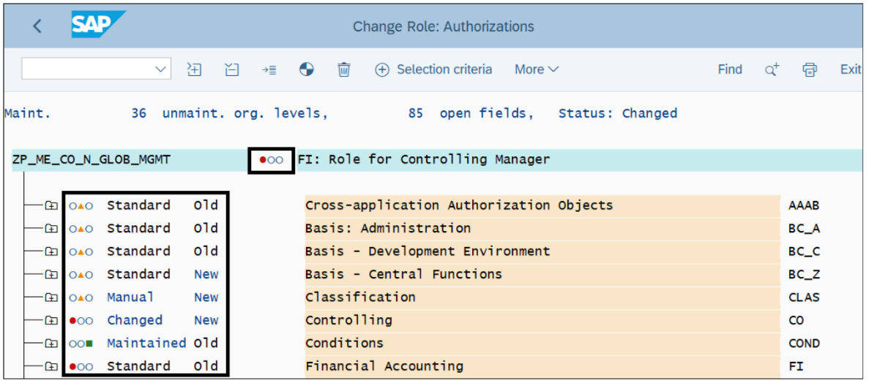

Traffic Light Icons: These icons give a quick visual summary of the maintenance status.
Colored Icon | Description
🟩 Green Square | All authorization field values are maintained.
🟨 Yellow Triangle | Open (unmaintained) authorization fields exist.
🟥 Red Circle | Unmaintained organizational levels exist.
Authorization Objects Maintenance Status Icons (From above attached screenshot)
- The main traffic light icon next to the role name (at the top of the authorization data screen) represents the status of the entire role profile.
- The icons next to each authorization object class indicate the maintenance status of the objects within that class.
Your objective is to maintain all open fields with necessary values to achieve a green light icon for all objects and for the role overall, or to deliberately inactivate fields/objects if they are not required. A fully green profile (no warnings about empty fields upon generation) means assigned users can functionally work with the applications in the role.
Maintenance Status Flags (Status Texts): These flags appear next to the descriptions of the authorization objects and provide more detail.
- Status: Standard
  - Indicates the role uses the unmodified proposal data directly from SU24 (table USOBT_C).
  - Except for organizational levels, you generally won't need to maintain anything further for these objects.
  - Example: Transaction FB03 might pull in object F_BKPF_BUK. If you later update the SU24 proposal for FB03 (e.g., add a display value) and merge this change into your role, the Profile Generator will automatically adjust the values, and the status might temporarily show as "Updated" to reflect this. (Below figure would show a standard object and an "Updated" instance after SU24 change)
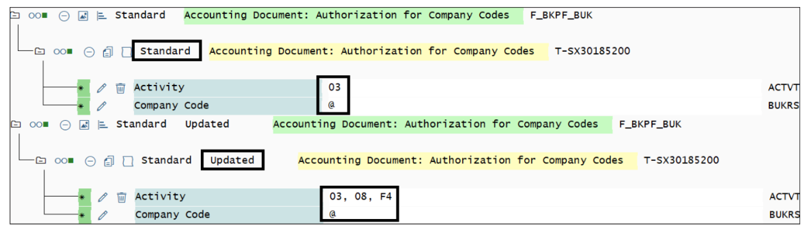
- Status: Maintained
  - An authorization object gets this status if its proposal values in SU24 contained at least one empty authorization field (in addition to organizational levels) which you then manually filled in within the role's authorization profile.
  - Having open fields in SU24 (leading to "Maintained" status in roles) is common and considered best practice when a single SU24 proposal value isn't appropriate for all roles that use the same application. This enables individualization during role maintenance. (Below figure would show a "Maintained" object and its where-used list)
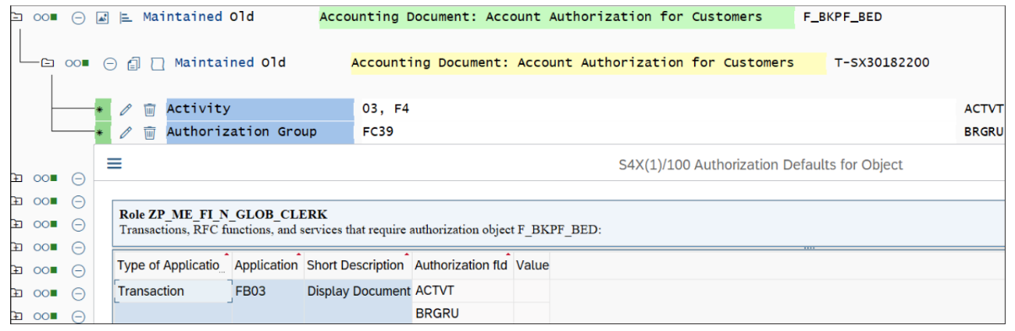
- Status: Changed
  - This status appears if you manually alter a standard proposal value (that came from USOBT_C) directly within the authorization object in the role, OR if you individually maintain organizational level fields directly within the object instead of using the central "Organizational Levels..." button.
  - Changing proposed standard authorizations directly in the role profile is NOT recommended. It bypasses the predefined SU24 values, can cause conflicts during upgrades, and significantly reduces role maintainability and security. (Below Figure would show a "Changed" object, with the system possibly inactivating the standard and creating a new active instance)
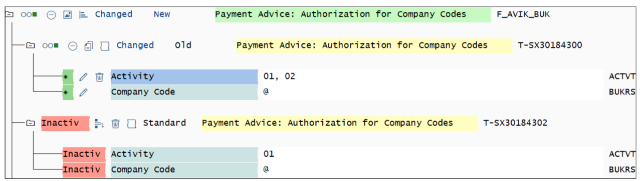
  - Hint (Basis version 7.50 and newer): If you change a related proposal (standard values) in the authorization profile, the Profile Generator automatically inactivates the original standard authorization object instance and offers the changed object as a new active instance. Do not delete these inactive standard authorization objects in the role; they provide a trace. The where-used list will still provide information about the relationship.
  - (Before Basis 7.50, if you used "Read old status and merge with new data," a changed object might have been reintroduced from SU24 as "New" alongside the "Changed" one, potentially creating orphaned entries.)
- ❗ Status: Manually
  - You can add authorization objects directly into an authorization profile using the "Manually" button in the header bar.
  - Such authorizations are not proposed through any role menu object.
  - This option is strongly NOT recommended and should only be used in rare, exceptional, and highly restrictive circumstances (e.g., specific value roles, certain SAP Solution Manager authorizations).
  - Drawbacks:
    - No link back to a transaction or other menu object.
    - The automatic profile merge mechanism (applying SU24 proposals) cannot work for manual objects.
    - You cannot use the where-used list to see the relationship between these authorizations and applications.
    - Often results in unmanageable and "orphaned" authorizations.
  - Before inserting manual authorizations, always consider updating SU24 to propose the intended authorizations instead.
  - Hint (Best practice for unavoidable manual authorizations): Document the absolute necessity of the manual object in its short text field within the authorization profile (e.g., by double-clicking the object's description and adding a comment like "- required for restricted archive actions in FI"). (Below figure would show a "Manually" introduced object)
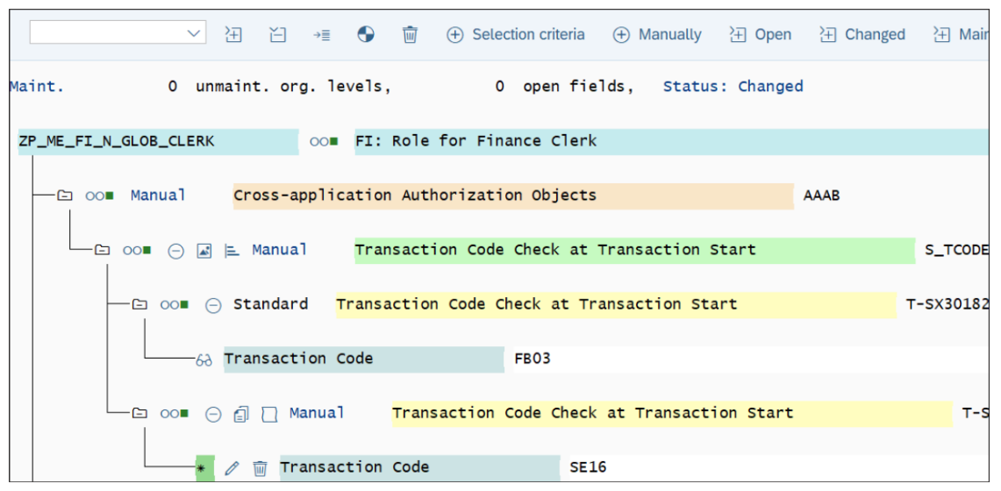
Best Practice Summary for Statuses: Aim to use Standard and Maintained statuses by adding applications through the role menu and maintaining any open fields. This leverages SU24 default values, simplifies role maintenance, and reduces risk during upgrades. Avoid using Changed or Manually statuses as they interrupt automatic proposals and reduce sustainability.
Disadvantages of Manual Authorizations (Recap):
- Cannot benefit from SU24 proposals.
- Deviates from SAP standard practices.
- Lack of clear information on the necessity of maintained manual authorizations.
- Difficult to assess why potentially critical or Segregation of Duties (SoD)-relevant objects are maintained.

Authorization Object Update Status Texts
Depending on your SU24 maintenance activities and how you've updated roles (e.g., using "Read old status and merge with new data"), you might see different authorization object update statuses in addition to the maintenance statuses discussed above.
Status | Short Description
Old | The authorization already exists in the current role profile, and no new proposals (values) have been introduced for it during an update of the role profile.
Updated | The authorization object already exists in the current role profile, but new proposal values have been introduced for it by updating the role profile (see SAP Note 871787).
New | The authorization object has been newly introduced into the role profile, either through new role menu objects or due to updated (newly added) proposals in SU24.
Hint: The "Maintained New" vs. "Maintained Old" Phenomenon You might encounter a situation where an update status like "Maintained New" for certain authorization objects doesn't change to "Maintained Old" even after regenerating the role profile.
- Reason: This often means you have two instances of the same authorization object linked to the same application. This can happen if the "Maintained New" instance has the same authorization fields as a "Maintained Old" instance, but a value has changed (e.g., from an empty field that was then maintained, or a standard value was changed).
- SAP's Intention: The system doesn't automatically decide whether to keep the old "maintained" values or accept the new "standard/updated" one. It retains the "New" status to flag that an administrator needs to decide how to handle these overlapping values and align them with specific business processes.
- Action: You need to investigate whether the "Maintained Old" authorization object and its specific values are still necessary or if the "Maintained New" instance supersedes it. You can then manually delete the redundant old instance if required.
- For more details, refer to SAP Notes:
  - 113290 - PFCG: Merge process for authorization data maintenance
  - 766483 - PFCG: Merging and combining authorizations (2)

Maintenance of Organizational Levels
Maintaining organizational level values (like Company Code, Plant, Sales Organization) is essential for restricting access according to your enterprise structure.
- Placeholders: Transaction proposals (SU24) often provide specific organizational fields as placeholders (e.g., $BUKRS for Company Code) based on AUTHORITY-CHECK statements.
- Your Task: You need to maintain specific values for these organizational levels in the role's authorization profile.
- Key Principle: Organizational level values are typically valid for the entire role and are applied equally to every relevant authorization object within that role that contains the specific organizational level field.
- Central Maintenance: To manage this, click the Organizational Levels... button in the header bar of the authorization profile maintenance screen. (Below figure would show the "Organizational Levels..." button)
  - A red circle icon next to the role's name (or an object class) indicates that unmaintained organizational levels exist. Click the button and maintain the required values.
- Once you centrally maintain an organizational value (e.g., Company Code 1000), every authorization object in that role containing the Company Code field (BUKRS) will inherit this value 1000.
Critical Best Practice: Use Central Maintenance ONLY!
- NEVER maintain different organizational level values separately within an individual authorization object. Always use the central "Organizational Levels..." button.
- Consequences of Direct Maintenance in Object:
  - Negatively impacts role administration effort, especially when using a role inheritance (master/derived) concept.
  - Can provoke audit issues.
  - Once you change an org level field directly in an object, you can no longer maintain it through the central function for that specific instance.
  - Since Basis version 7.50, the system deactivates the standard maintained org level instance and creates a new "changed" one, which then ignores values from central maintenance.
  - Manual org level maintenance in a master role can override the intended specific values in derived roles.
  - SAP displays an informational pop-up window when you attempt to manually change an organizational field directly within an authorization object to warn you. (Below Figure would show this information pop-up)
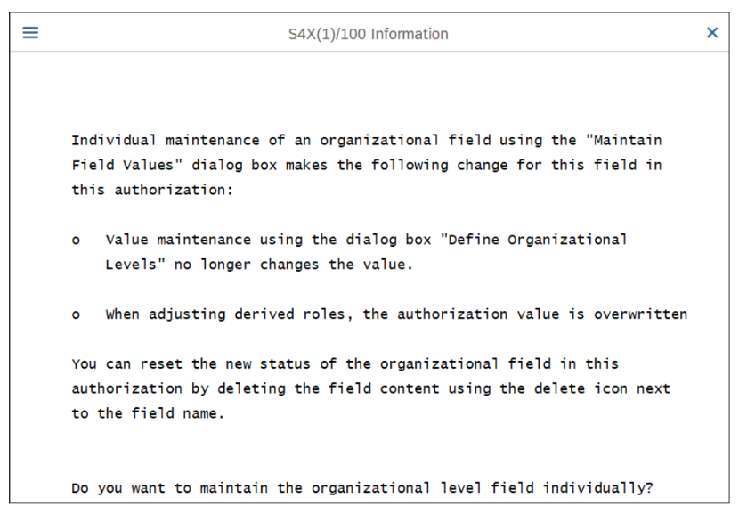
Hint: Reverting Manually Maintained Organizational Levels If you have manually maintained organizational levels directly in objects and want to revert to central maintenance:
- Attempt to revert the changes in the object.
- However, the system might still not introduce values from central maintenance for those specific objects.
- In such cases, you must run report AGR_RESET_ORG_LEVELS via Transaction SA38. This report resets manually maintained organizational fields and triggers the system to use the centrally maintained organization level values again. Then, you can maintain the values centrally.
Example of Correct Org Level Maintenance:
- A role menu with financial transactions has proposals leading to an empty authorization field for Company Code (BUKRS). The org level status icon is red. (Below Figure shows an unmaintained Company Code BUKRS)
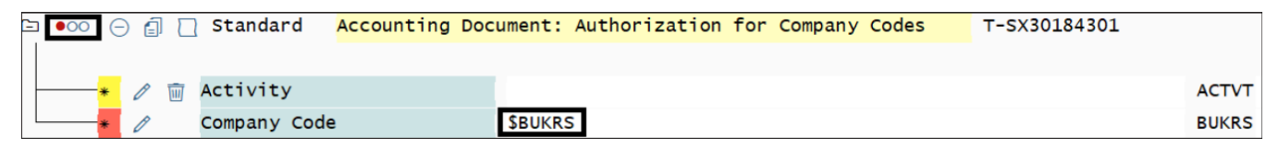
- Business requirement: Access for Company Code 1000.
- You click "Organizational Levels..." and maintain the value 1000 for the BUKRS field. (Below Fig shows Company Code maintained as 1000 centrally)
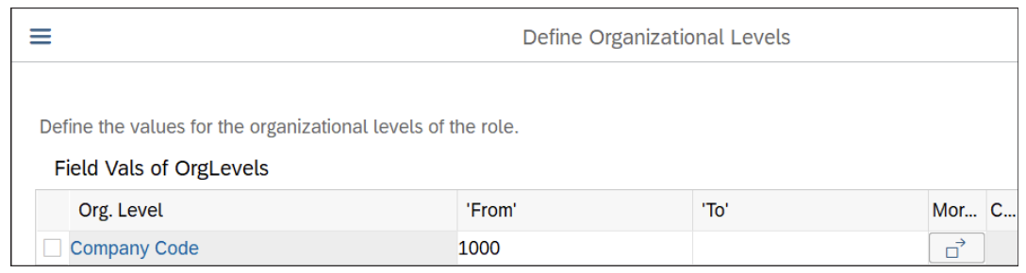
- Now, every authorization object in the role containing BUKRS gets the value 1000. The status icon turns green. End-users can use all applications in the role, restricted to Company Code 1000. ( Below Fig shows the maintained BUKRS with a green icon)
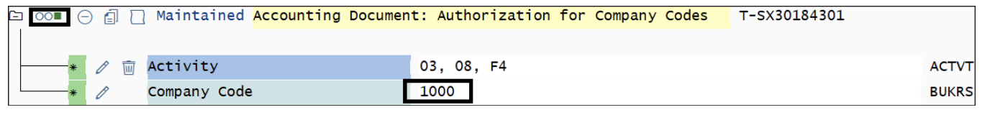
Advantages of Central Org Level Maintenance:
- Reduces role administration effort.
- Essential for building roles based on organizational restrictions and effectively using the derivation concept (master/derived roles).

Where-Used Lists
The where-used list within an authorization profile is an essential feature for maintaining your roles sustainably and understanding the origin of authorizations.
- Availability: You'll find these lists for each authorization object that has been pulled into the role based on the applications maintained in the role menu.
- Correlation with SU24: The where-used list is directly correlated to SU24 proposal data. It shows you which transaction or other menu object proposes those specific authorization objects, fields, and their default values. (Below Fig would show a where-used list for an object like F_BNKA_BUK, listing transactions that call it)
- If you change SU24 default values and merge them into the role, you’ll also see corresponding changes in the where-used list data.
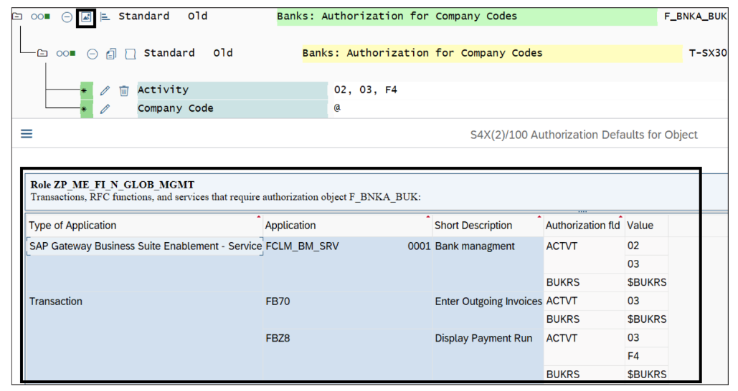
How to Use the Where-Used List:
- Maintaining Open Fields: Always consult the where-used list when trying to maintain open authorization fields (e.g., an empty ACTVT field). This tool can help you enter appropriate values according to an application’s intended purpose, especially if no specific business demands are clearly defined.
- Risk Remediation: It helps in understanding the context of an authorization, which is crucial for risk assessment.
- Example:
  - Suppose you have an open ACTVT (Activity) field for an object.
  - Check the where-used list for that object.
  - If the "Short Description" column for the linked applications/transactions indicates "Display" functions (e.g., "Display Vendor Master," "Display GL Document"), these typically require activity values like 03 (Display), 08 (Display Change Documents), and A8 (Display Archival Data - not F4 as in text) .
  - Therefore, you should only maintain these display-related values, instead of providing 01 (Create) or 02 (Change) access.
  - Consider customizing SU24 for these display applications to automatically propose the correct display-only access, thereby reducing your manual maintenance efforts in roles.

This concludes our detailed look into Authorization Maintenance. Mastering these concepts – the buttons, statuses, org level handling, and using where-used lists – is vital for building secure and efficient roles.

